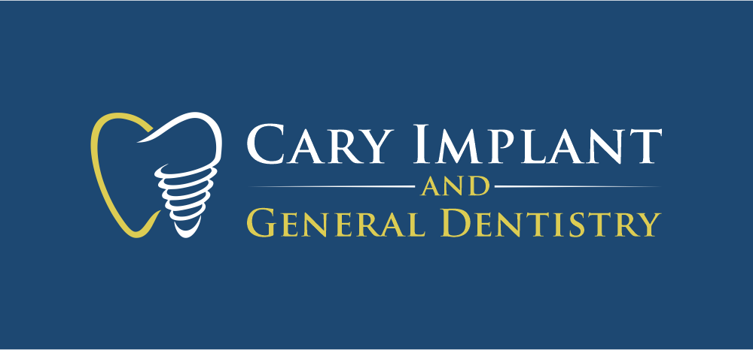
Cary Implant Dental Savings Plan
What is our Dental Savings Plan all about? Ultimately, it is a program for those patients who have no dental insurance coverage to receive discounted dentistry without the hassles of traditional dental insurance. Our main concern is making sure you have the best possible oral health and appearance, which is a critical factor in your overall health and well-being. We care about our patients, and that is why we are making it more affordable, while continuing to provide high-quality and efficient care.
How much does it cost?
- Adult: $439 per year
→ A Savings of $476!
- Adult Periodontal: $639 per year
→ A Savings of $804!
- Children (<14 yrs old): $239 per year
→ A Savings of $186!

What is included in my annual membership?
- Adult Benefits
  - 1 Comprehensive Exam
  - 1 Full X-ray Series
  - 2 Periodic Exams
  - 1 Emergency Exam*
  - 2 Fluoride applications
  - 2 Dental Cleanings
*Additional x-rays needed at emergency exams or outside of Benefits listed may not be included and may be subject to discounted rates only.

- Adult Periodontal Benefits:
  - 1 Comprehensive Exam
  - 1 Full X-ray Series
  - 2 Periodic Exams*
  - 1 Emergency Exam**
  - 2 Fluoride applications
  - 2 Periodontal Maintenance Cleanings***
* Additional periodic exams may be recommended by doctor to closely monitor any periodontal disease progression. Any additional exams needed will not be included and will be subject to discounted rate only.
**Additional x-rays needed at emergency exams or outside of Benefits listed may not be included and may be subject to discounted rates only.
***Additional maintenance cleanings may be recommended by doctor to prevent periodontal disease progression. Any additional cleanings needed will not be included and will be subject to discounted rate only.
- Child Benefits:
  - 1 Comprehensive Exam
  - 1 Set of Bitewing X-rays
  - 1 Panoramic X-ray
  - 2 Periodic Exams
  - 1 Emergency Exam*
  - 2 Fluoride applications
  - 2 Dental Cleanings
**Additional x-rays needed at emergency exams or outside of Benefits listed may not be included and will be subject to discounted rates only.

ADDITIONAL DISCOUNTS
Service | Discount (%)
CT (3D imaging) scans | 50% OFF
Deep Cleanings (SRP) | 20% OFF
Clear Orthodontic Aligners | $200 OFF
Teeth Whitening | $325 price
Dental Implant | 15% OFF
All Other Dental Treatment | 15% OFF

What are my responsibilities as a member?
- Entire membership fee must be paid up front and is valid for 12 months
- Membership fee is non-cancellable and non-refundable
- To receive discounts on treatment, treatment fee must be paid in full on the day of service, no exceptions.
- Failure to show or cancellation of a scheduled dental cleaning appointment without the required 48–hour notice will count as one of your dental cleaning occurrences and cannot be made up

Limitations and Exclusions
- Any treatment, which cannot be performed because of the general health and physical limits of the eligible Member, as indicated by said Member’s personal physician or our dentists.
- Any dental procedure considered experimental.
- Dispensing of drugs.
- Any treatment paid for by Worker’s Compensation or employer’s liability laws, by a federal or state government agency or other insurance coverage carried by the Member.
- The administration of general anesthesia, oral conscious sedation, or nitrous oxide.
- Any dental care in which you are referred to a specialist.
- Our office will have the right to refuse treatment to a Member who fails to follow a prescribed course of treatment.
- Any dental treatment started prior to the Member’s effective date for eligibility of benefits, including but not limited to teeth prepared for crowns, root canals in progress and orthodontics.
- Exclusions and treatment fees are subject to change without notice.
- If you acquire and use ANY 3rd party insurance plan during the 12-month contract period, this membership cannot be used and is non-refundable
- Periodontal Disease Deep Cleanings (SRPs) are not included in the annual fee, however are offered at a discounted price in the Dental Plan
- The Dental Savings Plan is only valid at Cary Implant and General Dentistry.
- This plan is non-refundable and non-cancelable and is only valid for 12 months during regular business hours at Cary Impland and General Dentistry

Cary Implant Dental Savings Plan Registration
Last Name________________________ First Name______________________ MI_______
Home Address_______________________________________________________________ City________________________________ State _____________ Zip Code______________
Phone #_______________________ Work Phone #_________________________________
Email address_________________________________ Birth Date______________________ Employer_______________________________
Plan type (chk one): Adult ($439) _____ Child ($239)______ Perio ($639) ______ Total $_________
Additional Family Members Birthdate Relationship _____________________________ _______________ ________________________ _____________________________ _______________ ________________________ _____________________________ _______________ ________________________ _____________________________ _______________ ________________________
Select Method of Payment
Circle one: Visa Mastercard Discover AmEx Debit Card Cash Check #_______

Charge Card Information:
Card #:____________________________ Expiration Date: __________ 3-digit code:______

Consents
I understand the benefits, limitations, exclusions, and requirements of the plan. Fees for dental services are due as the services are rendered. Failure to comply will result in my being charged the usual and customary fees for those services. Failure to show or cancellation of a scheduled dental cleaning appointment, without the required 48-hour notice, will count as one of your dental cleaning occurrences and cannot be made up. Fees are nonrefundable. If any 3 rd party insurance is acquired and used during the 12 month contract period, this membership cannot be used and is non-refundable.

Signature: _____________________________________________ Date_________________

FOR OFFICE USE:
Membership Start Date_______________ Membership End Date_______________

